Exp No: 30
RTOS TASK SCHEDULING
AIM:
To simulate Round-Robin scheduling
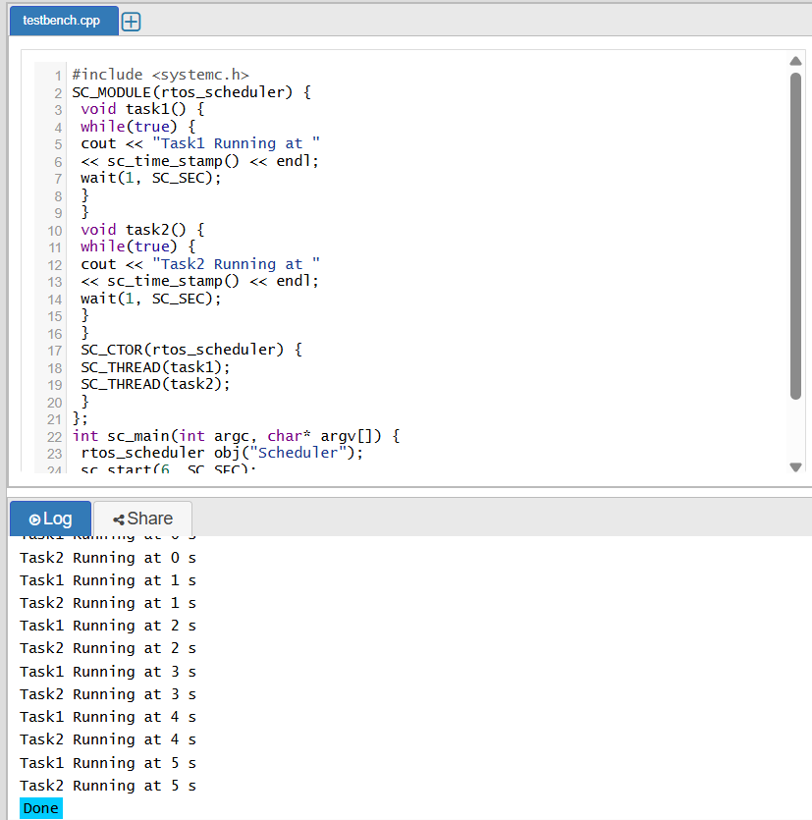
RESULT:
Thus the Round-Robin scheduling was executed using SystemC and verified

